- letters = "ABCDEFGHIJKLMNOPQRSTUVWXYZabcdefghijklmnopqrstuvwxyz"
# Write your unique_english_letters function here:
def unique_english_letters(word):
uniques = 0
for letter in letters:
if letter in word:
uniques += 1
return uniques
# Uncomment these function calls to test your function:
print(unique_english_letters("mississippi"))
# should print 4
print(unique_english_letters("Apple"))
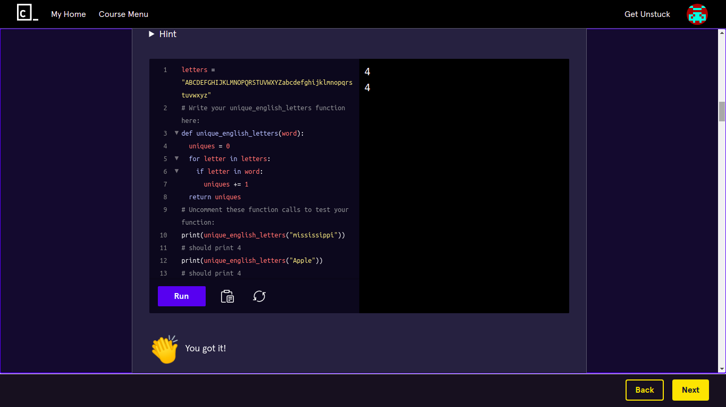
# should print 4

- # Write your count_char_x function here:
def count_char_x(word, x):
occurrences = 0
for letter in word:
if letter == x:
occurrences += 1
return occurrences
# Uncomment these function calls to test your tip function:
print(count_char_x("mississippi", "s"))
# should print 4
print(count_char_x("mississippi", "m"))
# should print 1
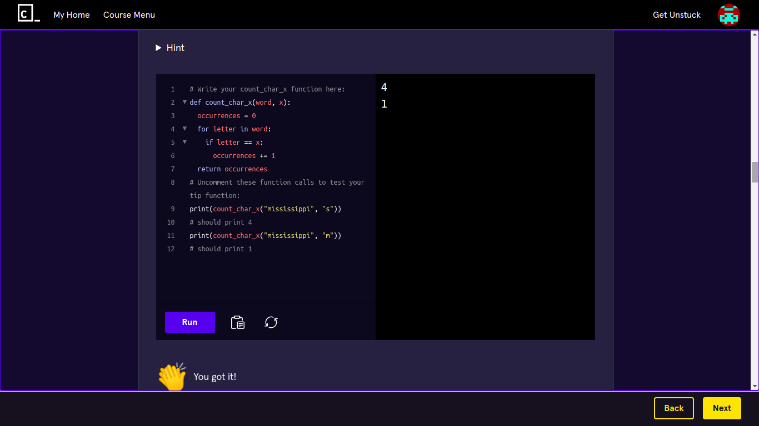

- # Write your count_multi_char_x function here:
def count_multi_char_x(word, x):
splits = word.split(x)
return(len(splits)-1)
# Uncomment these function calls to test your function:
print(count_multi_char_x("mississippi", "iss"))
# should print 2
print(count_multi_char_x("apple", "pp"))
# should print 1
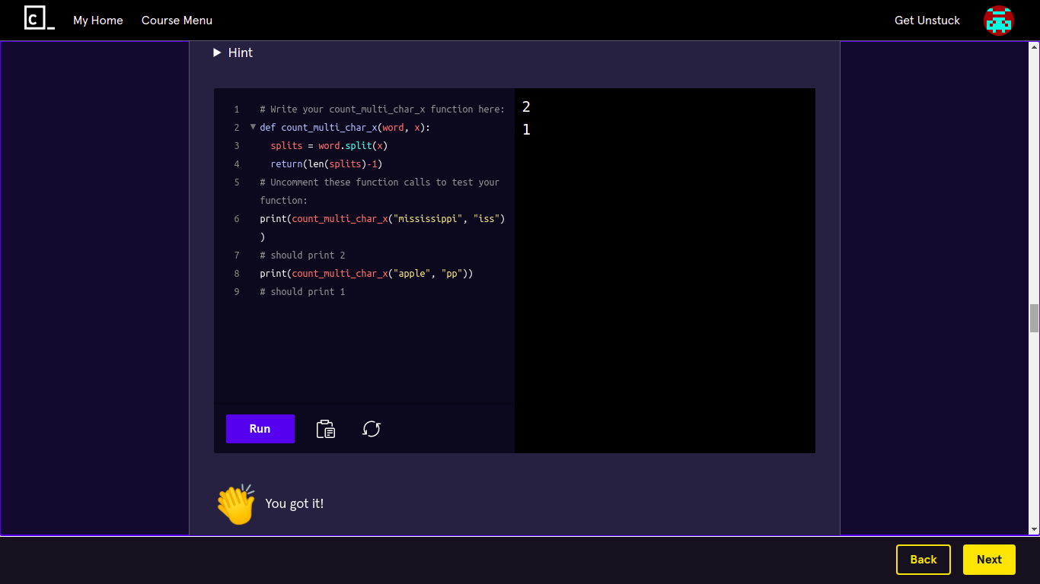

- # Write your substring_between_letters function here:
def substring_between_letters(word, start, end):
start_ind = word.find(start)
end_ind = word.find(end)
if start_ind > -1 and end_ind > -1:
return(word[start_ind+1:end_ind])
return word
# Uncomment these function calls to test your function:
print(substring_between_letters("apple", "p", "e"))
# should print "pl"
print(substring_between_letters("apple", "p", "c"))
# should print "apple"
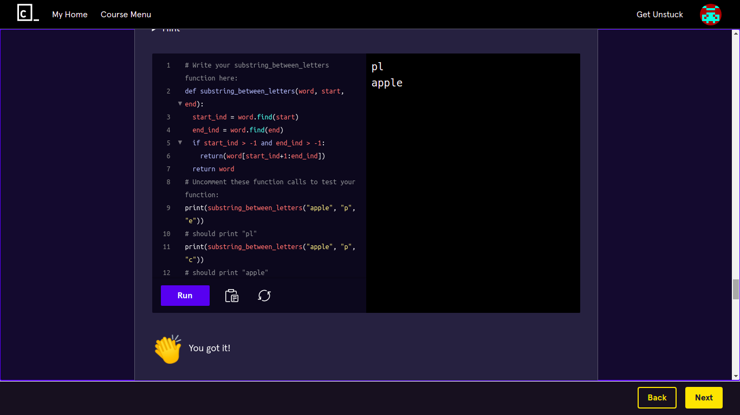

- # Write your x_length_words function here:
def x_length_words(sentence, x):
words = sentence.split(" ")
for word in words:
if len(word) < x:
return False
return True
# Uncomment these function calls to test your tip function:
print(x_length_words("i like apples", 2))
# should print False
print(x_length_words("he likes apples", 2))
# should print True

